RAY OPTICS
BASICS OF LIGHT AND REFLECTION
Light incident on any surface undergoes three primary physical phenomena: reflection (bouncing back into the same medium), absorption (taking up light energy), and refraction (bending upon passing into a different medium).
In reflection ray diagrams, the ray falling on the surface is the Incident Ray (IR), the point where it falls is the Point of Incidence, the perpendicular line drawn to the surface at the point of incidence is the Normal (N), and the ray bouncing back is the Reflected Ray (RR).
All geometric angles in optics are strictly measured from the Normal.
The Angle of Incidence (i) is the angle between the Incident Ray and the Normal, while the Angle of Reflection (r) is the angle between the Reflected Ray and the Normal.

The Laws of Reflection state:
1. The Incident Ray, the Normal, and the Reflected Ray all lie in the exact same physical plane. Mathematically, their box product or scalar triple product equals zero because they are coplanar.
2. The Angle of Incidence is always equal to the Angle of Reflection (i = r).
These laws of reflection are universally applicable to both smooth (regular) surfaces and rough (diffused) surfaces.
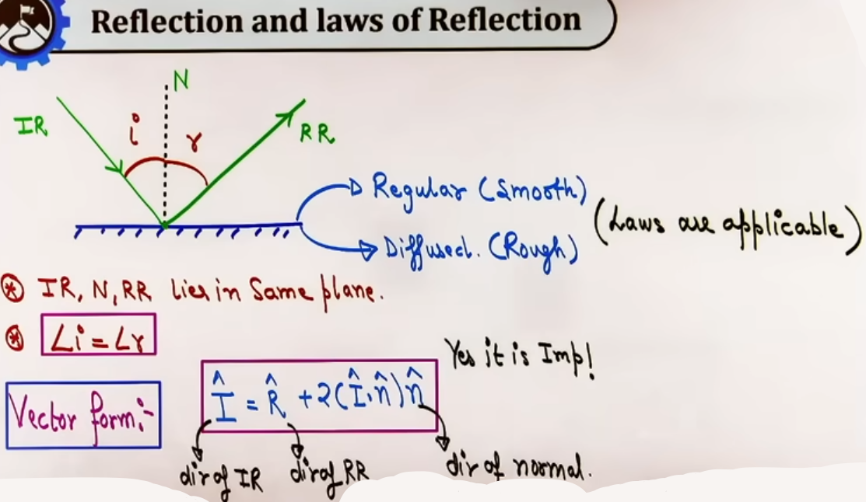
Vector Form of the Law of Reflection:
Let êᵢ be the unit vector along the incident ray direction, êᵣ be the unit vector along the reflected ray direction, and n̂ be the unit vector along the normal pointing outward into the medium of incidence.
The vector relation between incident ray, reflected ray, and normal is given by: êᵣ = êᵢ - 2(êᵢ · n̂)n̂.
Alternatively, if vector A represents incident direction, vector B represents reflected direction, and vector C represents normal direction, the relation is B = A - 2(A · C)C

Angle of Deviation (δ) by a Plane Mirror:
The angle of deviation is the angle through which a ray of light is turned from its original path upon reflection.
For an angle of incidence i, the deviation angle δ = 180° - 2i in clockwise or counter-clockwise sense depending on ray orientation.
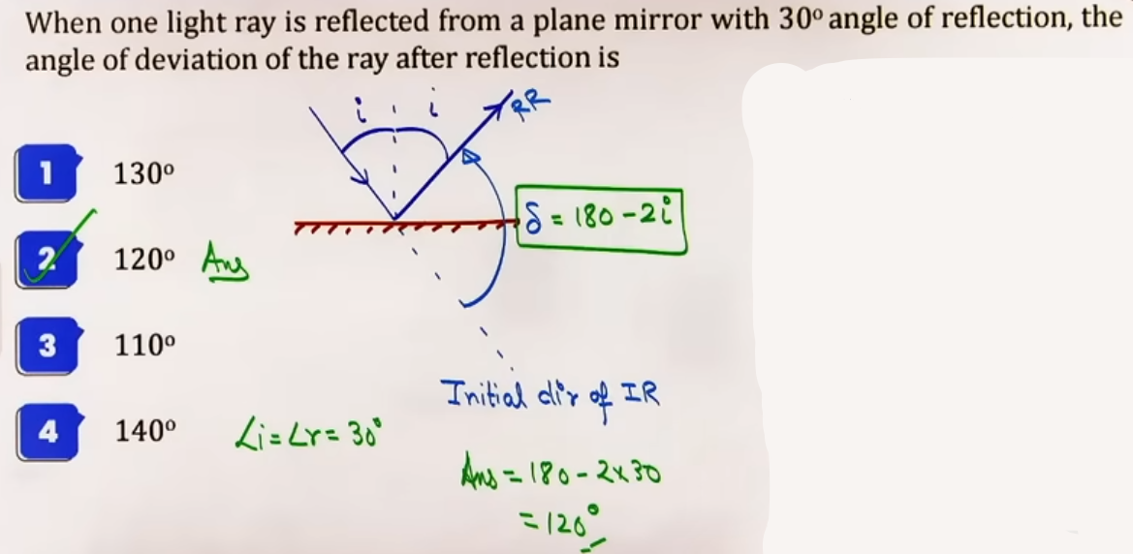
PLANE MIRROR BASICS AND IMAGE PROPERTIES
A plane mirror is constructed by taking a thin flat glass sheet and applying a silvered reflecting layer on its back surface.

Core Physical Properties of Plane Mirror Images:
1. Distance Equality: The perpendicular image distance from the mirror surface equals the perpendicular object distance from the mirror surface (xᵢ = xₒ).
2. Size Equality: The height or physical dimensions of the image equal the height or physical dimensions of the object (hᵢ = hₒ), giving a lateral magnification of exactly +1.
3. Nature Inversion: Real objects produce virtual images, while virtual objects produce real images.
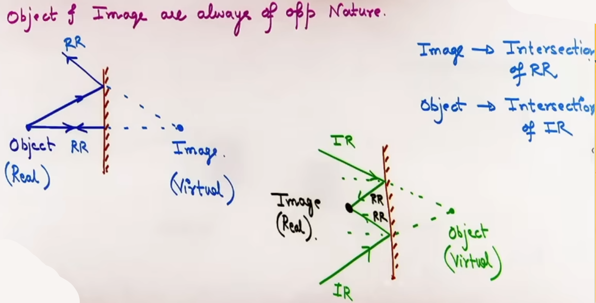
4. Definition of Object: An object is defined strictly as the point of intersection of Incident Rays (IRs). If incident rays physically originate from a point, it is a real object; if incident rays converge towards a point behind the mirror, it is a virtual object.
5. Definition of Image: An image is defined strictly as the point of intersection of Reflected Rays (RRs). If reflected rays physically converge to a real point, it is a real image; if reflected rays diverge and must be extended backward behind the mirror to intersect, it is a virtual image.
6. Lateral Inversion: The orientation of the image is laterally inverted (left appears right and right appears left), though vertically erect.
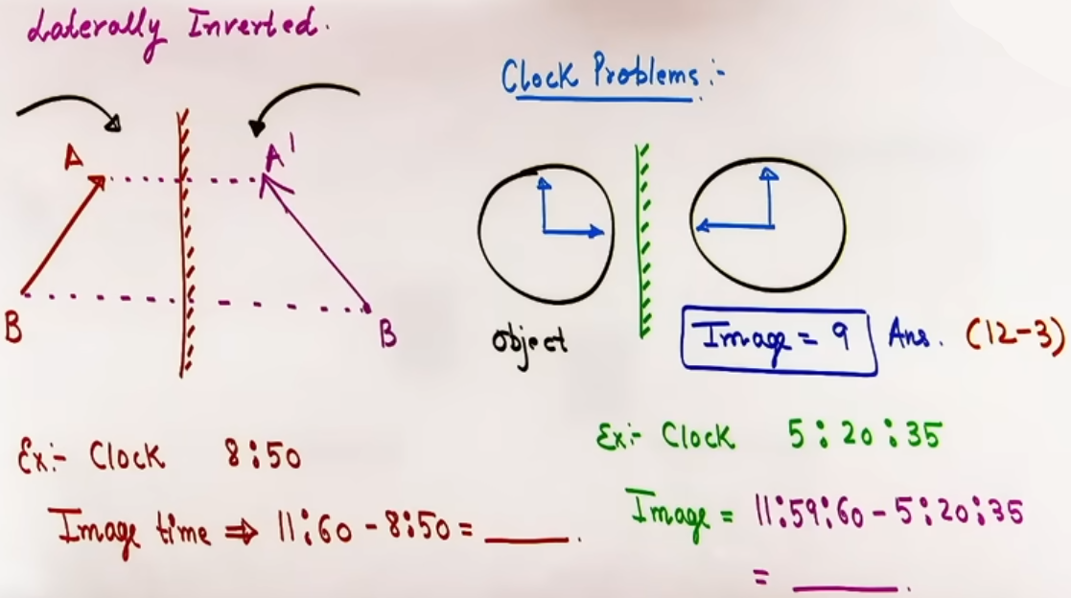
7. Clock Problems: Due to lateral inversion, an analog clock showing time T will produce an image time T_img obtained by subtracting T from 12:00:00 (represented as 11:60:00 or 11:59:60 for hours, minutes, and seconds).
8. Geometric Nature: Mathematically, a plane mirror acts as the perpendicular bisector of the line segment joining any object point and its corresponding image point.

ROTATION OF OBJECT AND MIRROR
Case 1: Rotation of Object (Mirror Fixed):
If the object is rotated by an angle θ about a fixed axis on or relative to the mirror, the image also rotates by the exact same angle θ in the OPPOSITE sense (e.g., if object rotates counter-clockwise by θ, image rotates clockwise by θ).
The distance of the image from the mirror remains equal to the object distance throughout the rotation.
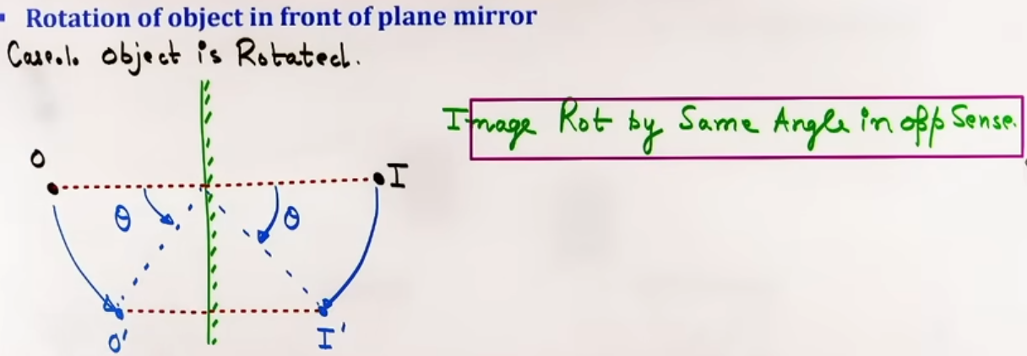
Case 2: Rotation of Mirror (Incident Ray Fixed):
If the mirror is rotated by an angle θ about an axis lying in its plane while keeping the incident ray fixed, the reflected ray (and the image) rotates by an angle of 2θ in the SAME sense (e.g., if mirror rotates clockwise by θ, reflected ray rotates clockwise by 2θ).
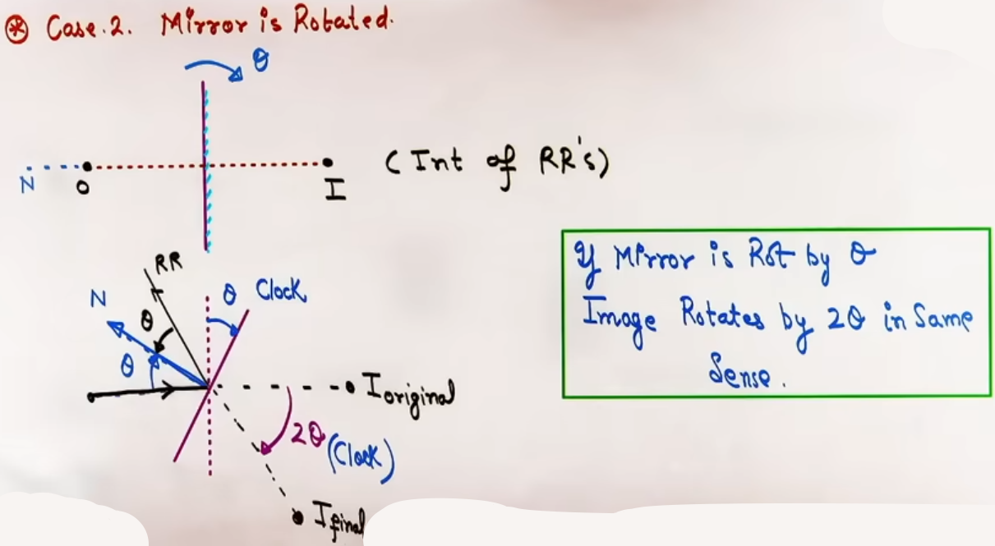
Case 3: Simultaneous Rotation of Object and Mirror:
When both the incident ray/object rotate with angular speed ω_O and the mirror rotates with angular speed ω_M, the net angular speed of the reflected ray/image ω_ref is found by superposition: ω_ref = -ω_O + 2ω_M (taking mirror rotation sense as positive).

MOTION AND VELOCITY IN PLANE MIRRORS

1. Object Motion Perpendicular to Mirror (Mirror at Rest):
When an object moves perpendicular to a stationary mirror with velocity vₒ⊥, the image moves with an equal magnitude but opposite direction in space:
vᵢ⊥ = -vₒ⊥
If the object moves towards the mirror at speed v, the image moves towards the mirror at speed v relative to ground, meaning the relative speed between object and image is 2v.
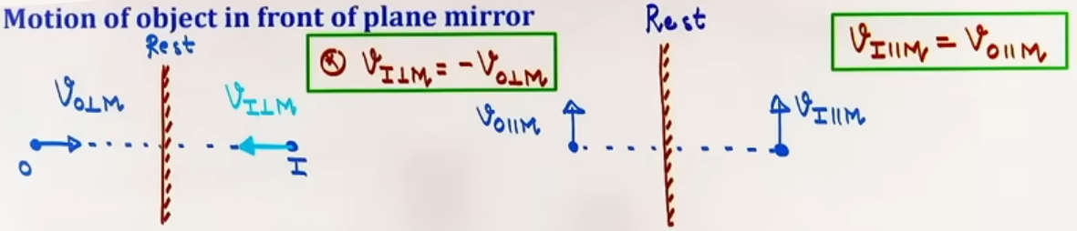
2. Object Motion Parallel to Mirror (Mirror at Rest):
When an object moves parallel to the surface of a stationary mirror with velocity vₒ∥, the image moves with the exact same velocity in magnitude and direction: vᵢ∥ = vₒ∥.

3. Mirror Motion Parallel to Itself:
Moving a plane mirror parallel to its own surface has zero impact on the velocity of the image (vᵢ = vₒ).
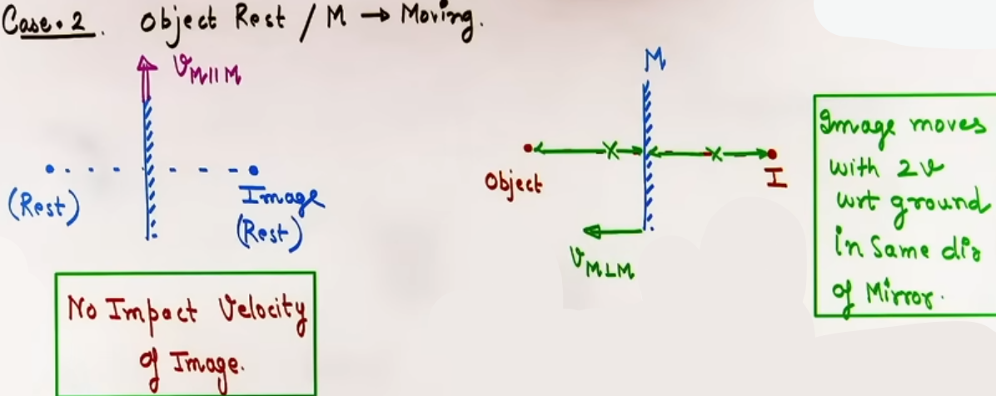
4. Mirror Motion Perpendicular to Itself (Object at Rest):
If a mirror moves perpendicular to its surface at velocity vₘ⊥ relative to ground, the image moves with twice the velocity of the mirror in the SAME direction relative to ground: vᵢ⊥ = 2vₘ⊥.
If a mirror moves a distance d towards or away from a stationary object, the image shifts by a distance 2d in the same direction relative to ground.

5. General Vector Master Equation for Perpendicular Motion:
In relative terms, image velocity relative to mirror equals negative of object velocity relative to mirror: (vᵢ⊥ - vₘ⊥) = -(vₒ⊥ - vₘ⊥).
- Solving for image velocity with respect to ground gives: vᵢ⊥ = 2vₘ⊥ - vₒ⊥.
- For total vector velocity in two dimensions: vᵢ = (2vₘ⊥ - vₒ⊥) î + (vₒ∥) ĵ.

NUMBER OF IMAGES FORMED BY INCLINED AND PARALLEL MIRRORS
When an object is placed between two plane mirrors inclined at an angle θ to each other, multiple reflections occur.

Step-by-step Calculation Procedure:
Step 1: Calculate the value N = 360° / θ.
Step 2: Check the nature of N:
- If N is EVEN:
Number of images n = N - 1 = (360° / θ) - 1, irrespective of whether the object is placed symmetrically (on the angle bisector) or asymmetrically.
- If N is ODD:
Case A: Object is placed SYMMETRICALLY (on the angle bisector):
Number of images n = N - 1 = (360° / θ) - 1.
Case B: Object is placed ASYMMETRICALLY (off the angle bisector):
Number of images n = N = 360° / θ.
- If N is FRACTIONAL:
The number of images is determined using the cross-pattern method of successive reflection angles up to total sum strictly less than 180°.

Parallel Mirrors (θ = 0°):
When two mirrors are placed parallel to each other facing one another, N = 360° / 0° = infinity, forming an infinite number of images.
“The exact positions of successive images behind each mirror are calculated by applying object distance = image distance iteratively for each reflection step.”

Perpendicular Mirrors (θ = 90°):
For two full perpendicular mirrors, N = 360° / 90° = 4 (even), so n = 4 - 1 = 3 images are formed.
- Two of these images are formed by single reflection from each individual mirror, while the third image is formed by combined double reflection.
- If the physical mirror surfaces are bounded such that reflected rays from one mirror cannot fall on the second mirror, only 2 single-reflection images are formed.

FIELD OF VIEW AND MINIMUM MIRROR SIZE

Field of View (FOV): Field of View is defined as the physical region in space bounded by the extreme reflected rays originating from the edges of the mirror, within which an observer's eye must be located to view the image.
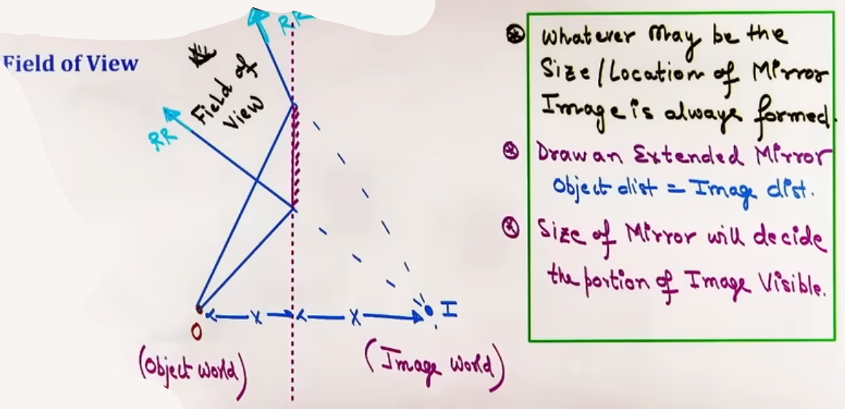
Key Fundamental Principles:
1. Image Formation vs. FOV: An image of an object is ALWAYS formed by a plane mirror regardless of the size, location, or orientation of the mirror, provided light rays can fall on the extended mirror plane. Mirror size and position only decide whether the image lies inside the visible FOV of a specific observer.
2. Ray Diagram Technique for FOV: To construct FOV, extend the plane mirror mathematically, locate the point image using object distance = image distance, and draw lines from the image point through the real physical edges of the mirror into the observer's space.
Minimum Mirror Size Calculations:
1. Minimum mirror size to FORM a complete image = A point-sized mirror forms a complete image (though visible FOV is tiny).
2. Minimum mirror height to SEE full self:
A person of height h requires a mirror of minimum vertical height = h / 2.
Height placement condition: The mirror must be placed such that its lower edge is at a height equal to half the height of the person's eyes from the ground (h_eye / 2).
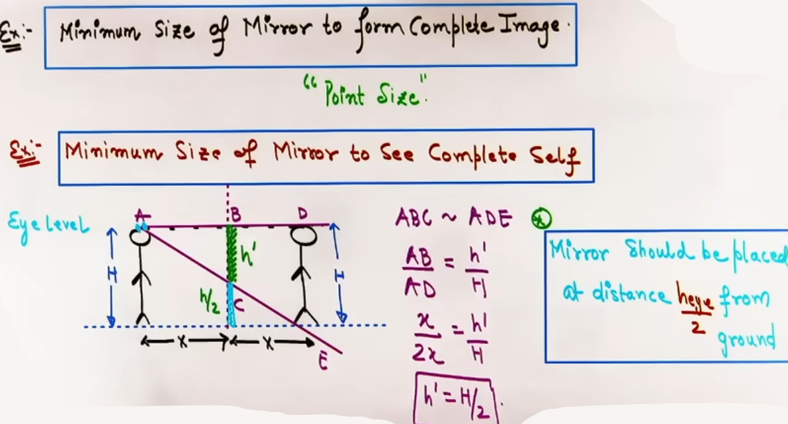
3. Minimum mirror size on front wall to SEE full back wall:
When an observer is standing at the exact midpoint between the front mirror and back wall of height H, the minimum height of mirror required on the front wall is H / 3.
If observer is at distance x from mirror and back wall of height H is at distance L behind observer (total distance from image of wall to observer = 2x + L), minimum mirror height = H × x / (2x + L).
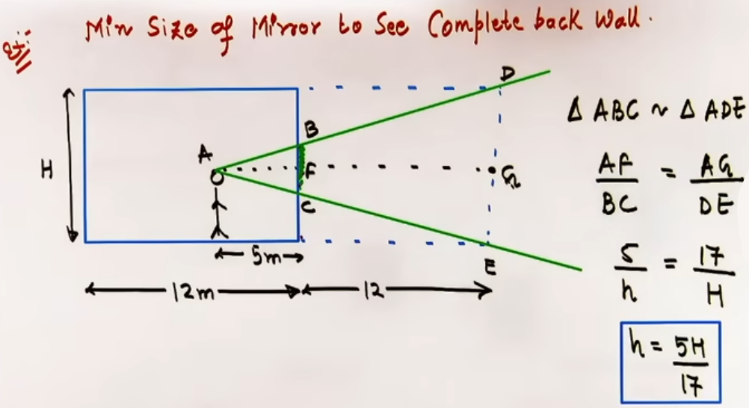
INTUITION AND CONCEPTUAL UNDERSTANDING
- Field of View as a Cone/Pyramid of Sight: Think of the image as a light source shining through the mirror opening. The mirror acts like a window frame; the light beam passing through the frame into space is the FOV.
- Object off to the side of a mirror: Students often think if an object is not directly in front of a mirror, no image forms. The teacher emphasizes: "Always draw an extended mirror line. The image is strictly created at the symmetric coordinate behind the extended line. Whether you can see it depends on whether your eye falls inside the extreme reflected rays.".
FORMULA SHEET
- Law of Reflection (Vector Form):
êᵣ = êᵢ - 2(êᵢ · n̂)n̂

- Angle of Deviation:
δ = 180° - 2i = π - 2i

- Clock Image Time:
Image Time = 11:59:60 - Given Time,

- Object and Mirror Rotation:
θ_image = -θ_object (when object rotates by θ)
θ_reflected_ray = 2 * θ_mirror (when mirror rotates by θ)
ω_reflected_ray = -ω_incident + 2 * ω_mirror,

- Image Velocity Vector Formula:
vᵢ⊥ = 2 * vₘ⊥ - vₒ⊥,
vᵢ∥ = vₒ∥,
vᵢ = (2 * vₘ⊥ - vₒ⊥) î + (vₒ∥) ĵ,

- Relative Shift when Mirror Moves:
Shift_image = 2 * Shift_mirror,

- Number of Images (Inclined Mirrors at angle θ):
N = 360° / θ
If N is Even: n = N - 1
If N is Odd and Symmetric: n = N - 1
If N is Odd and Asymmetric: n = N

- Field of View / Mirror Dimensions:
Minimum mirror height for full self-view = h / 2
Bottom edge mirror placement height = h_eye / 2
Minimum mirror height for back wall (observer at center) = H / 3,
Minimum mirror height for back wall = H * x / (2x + L),

PROBLEM-SOLVING FRAMEWORK
Question Type | Identification Clues | Approach / Strategy | Common Mistakes | Fast Methods / Shortcuts
Vector Form Law of Reflection | Unit vectors for incident ray and normal given | Apply êᵣ = êᵢ - 2(êᵢ · n̂)n̂ | Forgetting to check if normal vector is pointing outward | Identify normal component and invert its sign
Relative Velocity of Image | Both object and mirror moving at angles | 1. Resolve vₒ and vₘ into parallel and perpendicular components to mirror.  2. Apply vᵢ⊥ = 2*vₘ⊥ - vₒ⊥ and vᵢ∥ = vₒ∥.  3. Recombine vectors | Using wrong sign for directions; forgetting mirror motion doubles image speed | Work strictly in vector notation with î and ĵ along and normal to mirror
Parallel Mirror Image Distances | Object placed between two parallel mirrors | Draw step-by-step positions: I_A1 at d1, I_B1 at d2. Distance of I_B1 to Mirror A is d2 + D, so I_A2 is at d2 + D behind Mirror A | Mixing up distances measured from mirror A vs mirror B | Use simple addition: Next image distance = previous image distance in other mirror + gap between mirrors
EXAMPLES AND APPLICATIONS

Example 1: Combined Object and Mirror Motion
Problem: Object moves at 5 m/s at angle 53° to mirror normal (vₒ = 3 î + 4 ĵ m/s). Mirror moves towards object at 2√2 m/s at angle 45° to normal (vₘ = -2 î + 2 ĵ m/s). Find velocity of image and relative velocity of image w.r.t object.
Concept: Vector decomposition and 2D mirror motion formula.
Solution:
1. Perpendicular components (along î, normal to mirror):
vₒ⊥ = +3 m/s
vₘ⊥ = -2 m/s
vᵢ⊥ = 2*vₘ⊥ - vₒ⊥ = 2*(-2) - (+3) = -7 m/s (î direction).
2. Parallel components (along ĵ, parallel to mirror):
vₒ∥ = +4 m/s
vₘ∥ = +2 m/s (has no effect on image parallel velocity),
vᵢ∥ = vₒ∥ = +4 m/s (ĵ direction).
3. Total Image Velocity relative to ground:
vᵢ = -7 î + 4 ĵ m/s.
4. Relative Velocity of Image w.r.t Object:
vᵢ/O = vᵢ - vₒ = (-7 î + 4 ĵ) - (3 î + 4 ĵ) = -10 î m/s.
Answer: Image velocity = -7 î + 4 ĵ m/s; Relative velocity w.r.t object = -10 î m/s.

Example 2: Successive Reflection Image Distances in Parallel Mirrors
Problem: Two parallel plane mirrors A and B are separated by 10 cm. A point object O is placed 2 cm from mirror A (8 cm from mirror B). Find the distance of the second image formed behind mirror A.
Concept: Iterative reflection image distances.
Solution:
1. First image behind Mirror A (I_A1) is at distance = 2 cm.
2. First image behind Mirror B (I_B1) is at distance = 8 cm.
3. Distance of I_B1 from Mirror A = 8 cm + 10 cm (gap) = 18 cm.
4. I_B1 acts as virtual object for Mirror A, so second image behind Mirror A (I_A2) is formed at distance = 18 cm behind Mirror A.
Answer: 18 cm behind mirror A.

Example 3: Field of View for Back Wall
Problem: A point source B is at distance L from a mirror of width d. A man walks along a line parallel to mirror at distance 2L from mirror (3L from image). Find the maximum distance over which he can see the image.
Concept: Similar triangles between image, mirror edges, and walking line.
Solution:
1. Image is formed at distance L behind mirror.
2. Distance from image to mirror = L.
3. Distance from image to observer's walking line = L + 2L = 3L.
4. By similar triangles: FOV_width / mirror_width = 3L / L.
5. FOV_width / d = 3 => FOV_width = 3d.
Answer: 3d.

JEE ADVANCED INSIGHTS

- Edge Case in Perpendicular Mirrors (90°):
Standard formula gives n = 360/90 - 1 = 3 images.
However, if the two mirrors do not join at the corner or have a physical gap, rays reflected from one mirror cannot hit the second mirror. In this restricted geometry, no combined double-reflection image is formed, resulting in ONLY 2 images instead of 3.

- Image Velocity Traps:
Moving a mirror by 4 cm towards an object shifts the image by 8 cm relative to ground, BUT the distance between object and image decreases by 8 cm, whereas image distance from the mirror decreases by 4 cm. Always distinguish between "shift relative to ground" and "shift relative to mirror".
--------------------------------------------------------------------------------
SPHERICAL MIRRORS
Spherical mirrors are reflecting surfaces formed by taking a section of a hollow glass sphere and silvering one of its surfaces.
- If the reflecting surface is curved inwards like a cave, it is called a Concave Mirror (Converging).
- If the reflecting surface bulges outwards, it is a Convex Mirror (Diverging).

Key Definitions and Parameters:
- Center of Curvature (C) is the geometric center of the parent sphere from which the spherical mirror was cut.
- Pole (P) is the geometric center or midpoint of the spherical mirror surface.
Principal Axis is the straight line passing through the Pole and the Center of Curvature.
- Radius of Curvature (R) is the distance from the Pole to the Center of Curvature.
- Focus or Focal Point (F) is the point on the principal axis where paraxial rays parallel to the principal axis converge after reflection (in concave mirrors) or appear to diverge from (in convex mirrors).
- Focal Length (f) is the distance between the Pole and the Focus.
The focal length of a spherical mirror is given by f = R/2.
The focal length of a mirror depends solely on its geometry and radius of curvature, making it completely independent of the surrounding medium.

Paraxial and Marginal Rays:
- Paraxial rays are incident light rays that lie extremely close to the principal axis and make very small angles with the normal.
- Marginal rays fall far from the principal axis and make larger angles of incidence.
- In standard optics and JEE syllabus, small angle approximations apply strictly to paraxial rays. # only paraxial rays in syllabus
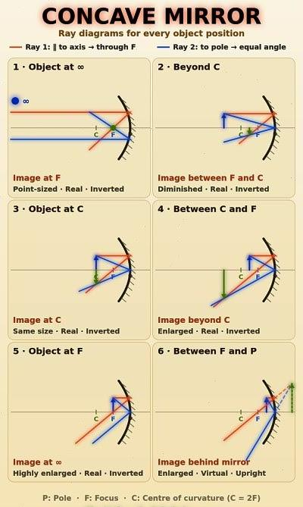
Ray Diagrams and Image Formation in Concave Mirrors:
1. Object at Infinity: Image is formed at Focus (F); it is Real, Inverted, and highly Diminished (point-sized).
2. Object Beyond C: Image is formed between C and F; it is Real, Inverted, and Diminished.
3. Object at C: Image is formed at C; it is Real, Inverted, and Same Size as object.
4. Object Between C and F: Image is formed Beyond C; it is Real, Inverted, and Magnified.
5. Object at F: Image is formed at Infinity; it is Real, Inverted, and highly Magnified.
6. Object Between Focus (F) and Pole (P): Image is formed Behind the Mirror; it is Virtual, Erect, and Magnified. This is the only position where a concave mirror produces a virtual image for a real object.
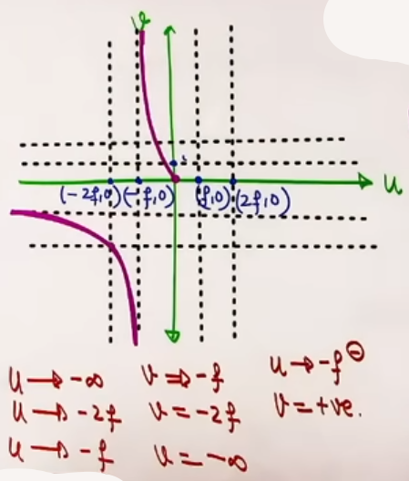

Image Formation in Convex Mirrors:
- For any real object placed anywhere in front of a convex mirror, the image is always formed behind the mirror between P and F.
- The image produced by a convex mirror for a real object is strictly Virtual, Erect, and Diminished.
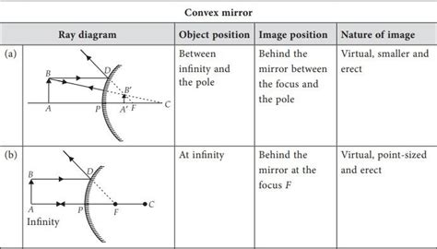
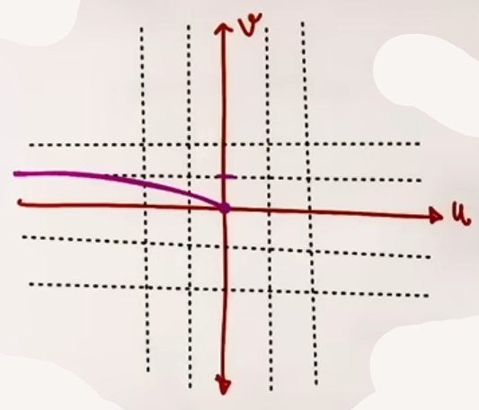

Sign Convention for Spherical Mirrors:
1. All distances are measured strictly from the Pole (P) along principal axis.
2. The direction of the Incident Ray is taken as POSITIVE.
3. Distances measured in the direction of the incident ray are POSITIVE, while distances measured opposite to the incident ray direction are NEGATIVE.
4. Heights measured perpendicularly above the principal axis are POSITIVE, while heights measured perpendicularly below the principal axis are NEGATIVE.

Mirror Formula:
The algebraic relation connecting object distance (u), image distance (v), and focal length (f) is given by: 1/f = 1/v + 1/u.
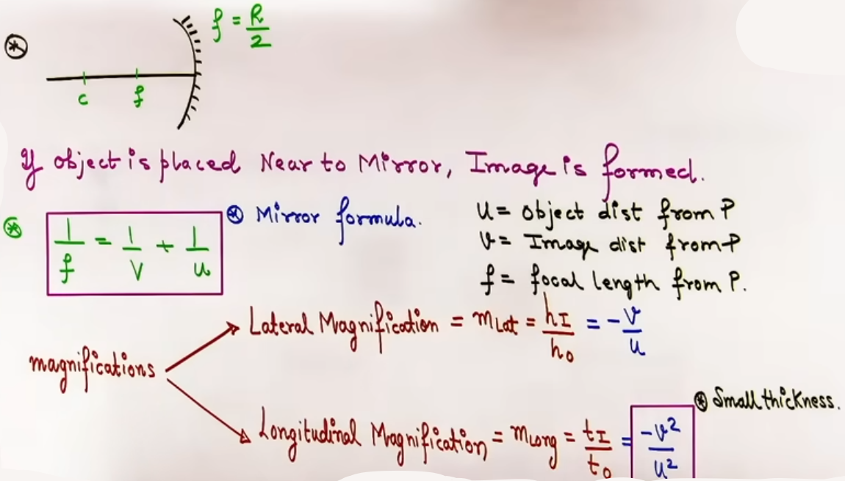
Magnification in Spherical Mirrors:
1. Transverse or Lateral Magnification (mₗ):
Ratio of image height (hᵢ) to object height (hₒ) perpendicular to the principal axis.
mₗ = hᵢ/hₒ = -v/u.
If mₗ is negative, the image is inverted relative to the object.
If mₗ is positive, the image is erect relative to the object.

2. Longitudinal Magnification (m_long):
Ratio of image length/thickness to object length/thickness along the principal axis.
- For small longitudinal object thickness (du), m_long = -v² / u² = -(mₗ)².
- For large longitudinal object thickness (t_u) extending from u₁ to u₂, calculate the corresponding image boundaries v₁ and v₂ individually using the mirror formula, then evaluate m_long = t_i/t_u = (v₂ - v₁) / (u₂ - u₁).

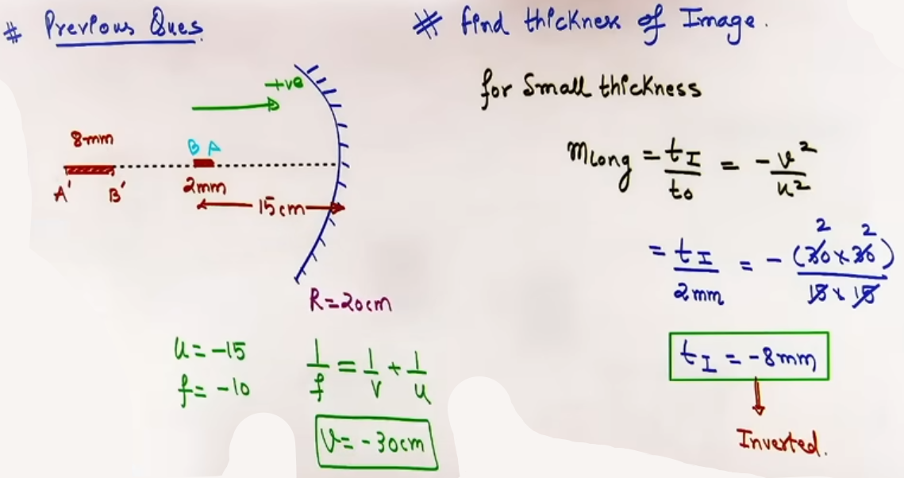
Velocity Magnification in Spherical Mirrors:
When an object moves in front of a spherical mirror, image velocity is evaluated along components.
1. Object moving parallel to the principal axis:
vᵢ∥ = m_long * vₒ∥ = -(v² / u²) * vₒ∥.
The negative sign indicates that if an object moves towards the mirror along the axis, its real image moves away from the mirror.

2. Object moving perpendicular to the principal axis:
vᵢ⊥ = mₗ * vₒ⊥ = (-v / u) * vₒ⊥.
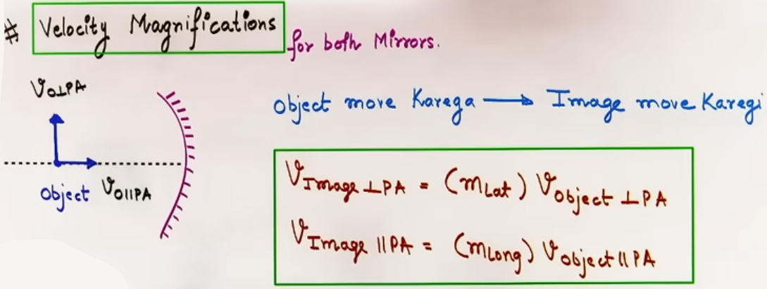
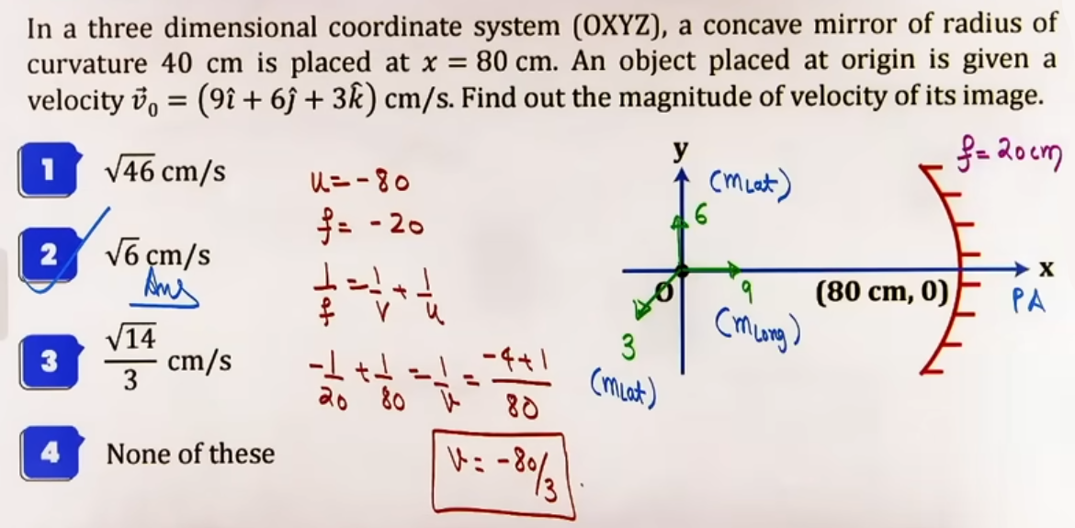
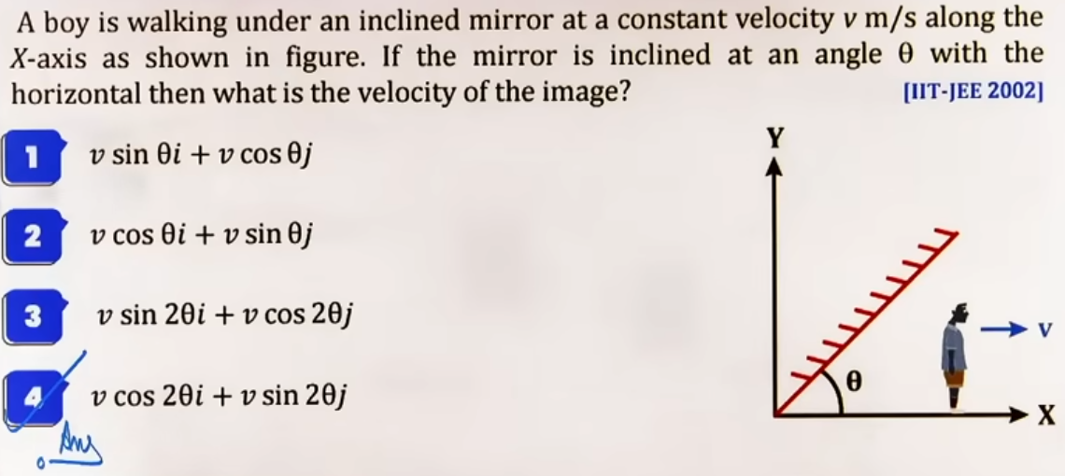

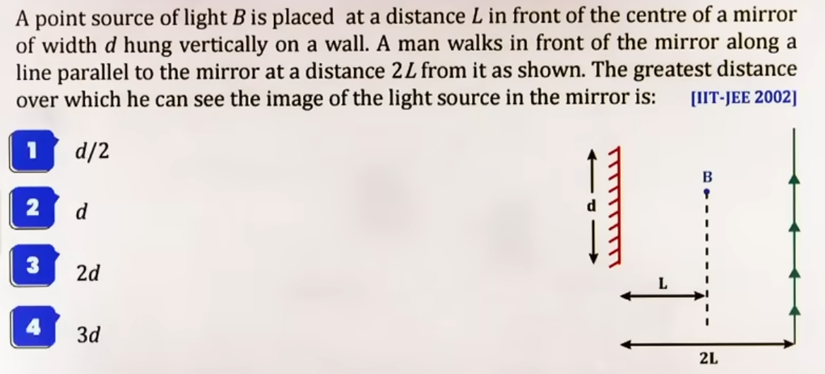
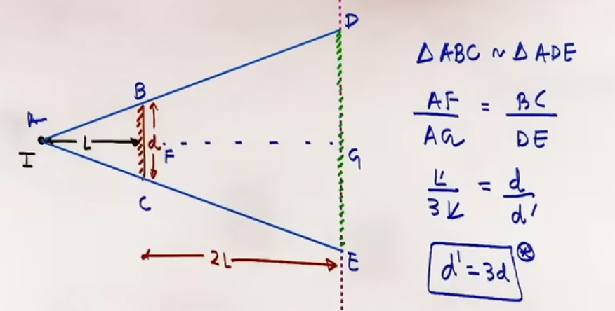

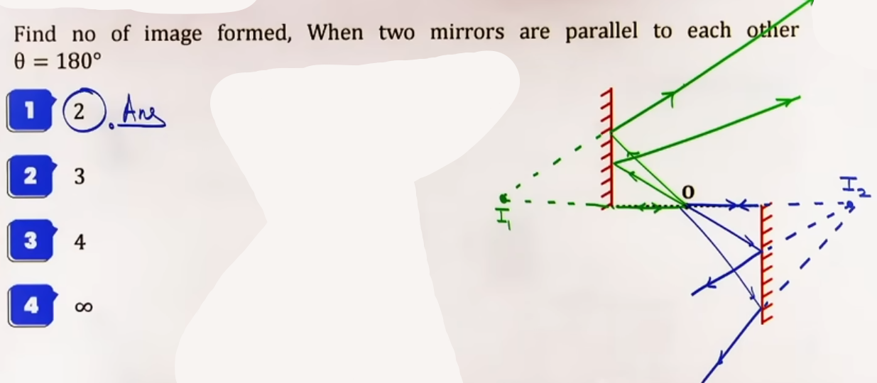
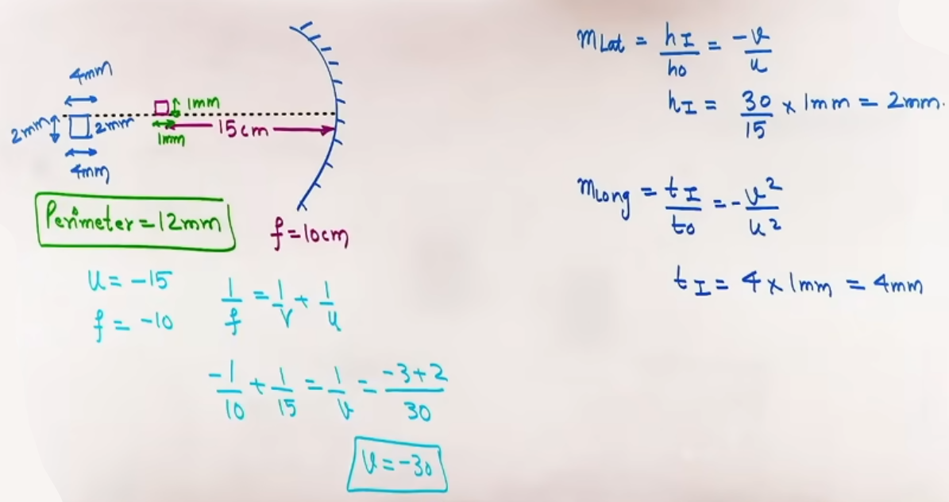
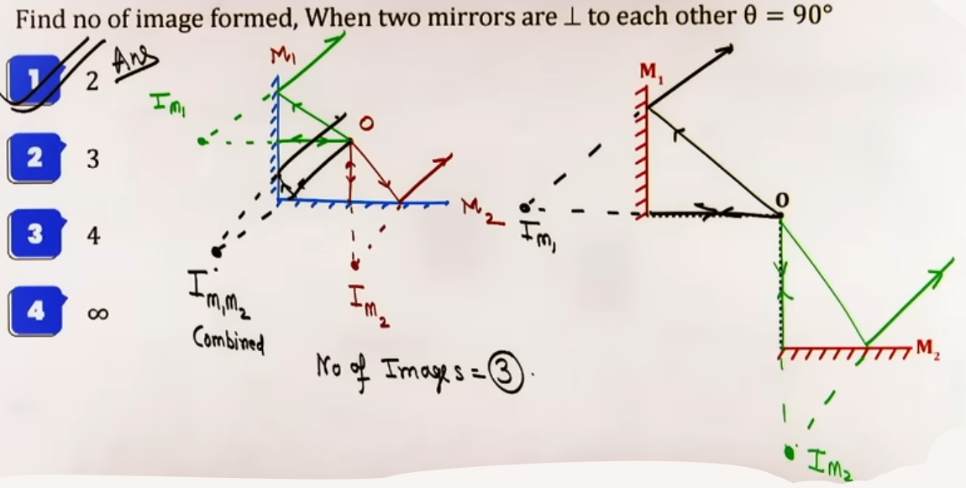

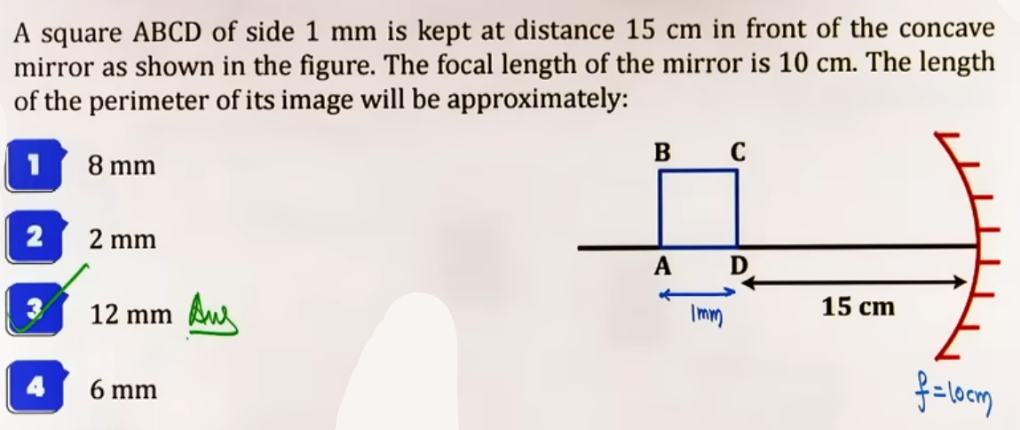
REFRACTION OF LIGHT AND REFRACTIVE INDEX
Refraction is the physical phenomenon of bending or deviation of a ray of light from its original path when it passes obliquely from one transparent medium into another.

Fundamental Behavior of Wave Parameters in Refraction:
Frequency (f or ν) of light depends strictly on the light source and remains completely UNCHANGED when passing across different media.
Velocity (v) and Wavelength (λ) of light CHANGE when passing from one medium to another.
Since v = f * λ, velocity and wavelength are directly proportional in any given medium.
@ photo - 25

Absolute Refractive Index (μ):
The measure of optical density of a medium defined as the ratio of speed of light in vacuum (c) to the speed of light in that medium (v).
μ = c / v = λ₀ / λ_medium.
Since speed of light in vacuum is maximum, the absolute refractive index μ of any physical medium is always strictly greater than 1 (μ > 1).

Relative Refractive Index (μ₁₂ or ₁μ₂):
Refractive index of medium 2 with respect to medium 1.
μ₁₂ = μ₂ / μ₁ = v₁ / v₂ = λ₁ / λ₂.
Relative refractive index can be greater than 1 or less than 1 depending on the ratio of optical densities of the two media.

Laws of Refraction:
1. The incident ray, the normal to the refracting interface at the point of incidence, and the refracted ray all lie in the same physical plane.
2. Snell's Law: For light of a given color and for a given pair of media, the ratio of the sine of the angle of incidence (i) to the sine of the angle of refraction (r) is constant.
μ₁ sin i = μ₂ sin r, or μ sin θ = constant.
@ photo - 26

Bending Rules:
When light travels from an optically Rarer medium (lower μ) to a Denser medium (higher μ), μ increases, so angle θ decreases; light bends TOWARDS the normal (i > r).
When light travels from an optically Denser medium (higher μ) to a Rarer medium (lower μ), μ decreases, so angle θ increases; light bends AWAY from the normal (i < r).

REFRACTION THROUGH GLASS SLAB
A glass slab is a transparent medium bounded by two parallel plane refracting surfaces separated by a distance t (thickness).

Physical Properties of Slab Refraction:
When a ray of light enters a glass slab from air, it bends towards the normal at the first surface, travels through the slab, and bends away from the normal at the second surface.
If the surrounding medium on both sides of the glass slab is identical, the angle of incidence (i) at the first surface equals the angle of emergence (e) at the second surface (i = e).
The emergent ray is parallel to the incident ray direction but shifted laterally sideways by a perpendicular distance called Lateral Shift (d).

Lateral Shift Formula:
d = t * sin(i - r) / cos r.
For small angles of incidence (i):
d ≈ t * i * (1 - 1 / μ).
@ photo - 27

Normal Shift by a Glass Slab:
When an object is viewed normally through a flat glass slab of thickness t and refractive index μ, the object appears shifted closer to the observer along the normal.
Apparent Depth (d_apparent) = t / μ.
Normal Shift (S) = t * (1 - 1 / μ).
Key Insight: The normal shift produced by a flat glass slab depends strictly on its thickness (t) and refractive index (μ), and is completely INDEPENDENT of the position/distance of the object from the slab.

Multiple Liquid Layers or Composite Slabs:
If an observer views an object through multiple parallel layers of thicknesses t₁, t₂, t₃... and refractive indices μ₁, μ₂, μ₃..., the total normal shift is given by,:
S_total = Σ t_i * (1 - 1 / μ_i) = t₁*(1 - 1/μ₁) + t₂*(1 - 1/μ₂) + t₃*(1 - 1/μ₃) + ....
Total Apparent Depth = Σ (t_i / μ_i).

TOTAL INTERNAL REFLECTION (TIR)
Total Internal Reflection is the optical phenomenon in which light traveling from an optically denser medium to a rarer medium is completely reflected back into the denser medium without any refraction.
@ photo - 28

Necessary Conditions for TIR:
1. Light must travel from an optically DENSER medium towards an optically RARER medium.
2. The angle of incidence (i) in the denser medium must be strictly GREATER than the Critical Angle (θ_c) for the pair of media (i > θ_c).

Critical Angle (θ_c):
The angle of incidence in the denser medium for which the angle of refraction in the rarer medium becomes exactly 90 degrees (r = 90°).
By Snell's Law: μ_denser * sin θ_c = μ_rarer * sin 90°.
sin θ_c = μ_rarer / μ_denser.
If the rarer medium is air/vacuum (μ_rarer = 1), then sin θ_c = 1 / μ.
θ_c = sin⁻¹(1 / μ).

Circle of Illuminance (Area of Illuminance / Fish-Eye View):
A point source of light submerged at a depth h inside an optically denser liquid (refractive index μ) emits light in all directions.
Rays hitting the liquid-air interface at angle i < θ_c refract out into air.
The ray hitting at i = θ_c emerges grazing the surface (r = 90°).
Rays hitting at i > θ_c undergo TIR and cannot escape into air.
Thus, light emerges from the surface only through a circular region of radius R.
Radius of Circle of Illuminance: R = h * tan θ_c = h / √(μ² - 1).
Area of Illuminance: A = π * R² = π * h² / (μ² - 1).
@ photo - 32.1, 32.2

Brewster's Law and Polarization Connection:
When light is incident at a specific Brewster's angle (i_B) such that the reflected ray and refracted ray are mutually perpendicular (i_B + r = 90°), the reflected light is completely unpolarized to plane-polarized.
By Snell's Law: tan i_B = μ.
@ photo - 31

Color Separation by TIR:
Since refractive index μ varies inversely with wavelength λ (Cauchy's equation: μ ∝ 1/λ), violet light has a higher μ than red light (μ_violet > μ_red).
Consequently, critical angle varies inversely with μ: θ_c,violet < θ_c,red.
If composite white light is incident at a fixed boundary angle equal to θ_c for green light, colors with shorter wavelengths (violet, indigo, blue) have smaller θ_c, so their angle of incidence exceeds their critical angle and they undergo TIR back into the medium. Colors with longer wavelengths (yellow, orange, red) have larger θ_c, so they refract out into the rarer medium.
@ photo - 33
@ photo - 29

---- qs
@ photo - 30
@ photo - 34.1, 34.2
@ photo - 35 # ye graph bhi imp h
----
?? (after prisms)
REFRACTION AT SPHERICAL SURFACES
When a spherical boundary of radius of curvature R separates two media of refractive indices μ_initial (medium containing incident rays) and μ_final (medium containing refracted rays), light undergoes single-surface refraction.

Refraction Formula for Single Spherical Surface:
μ_final / v - μ_initial / u = (μ_final - μ_initial) / R.
@ photo - 45

Sign Convention Rules for Refraction at Spherical Surface:
1. All distances are measured from the Pole / Vertex (O) of the spherical surface along the optical axis.
2. Direction of incident light rays is POSITIVE.
3. Distances measured in direction of incident light are POSITIVE; distances measured opposite to incident light direction are NEGATIVE.
4. Center of curvature position determines the sign of Radius of Curvature (R): if C lies on the positive side, R is positive (convex surface to incident ray); if C lies on the negative side, R is negative (concave surface to incident ray).

Magnification at Spherical Refracting Surface:
1. Lateral / Transverse Magnification (m_L):
m_L = h_i / h_o = (μ_initial / μ_final) * (v / u).

2. Longitudinal Magnification (m_long):
For small object thickness along axis:
m_long = thickness_i / thickness_o = (μ_initial / μ_final) * (v² / u²).

Velocity Magnification at Spherical Refracting Surface:
1. Parallel to principal axis:
v_I,∥ = m_long * v_O,∥ = (μ_initial / μ_final) * (v² / u²) * v_O,∥.
2. Perpendicular to principal axis:
v_I,⊥ = m_L * v_O,⊥ = (μ_initial / μ_final) * (v / u) * v_O,⊥.

----qs
@ photo - 46
@ photo - 47
@ photo - 48
@ photo - 49.1, 49.2

2. INTUITION AND CONCEPTUAL UNDERSTANDING

Mental Models and Visualizations:
- Mirror Image Space as a Reversed Coordinate Grid:
Visualize a spherical mirror as an inverted optical machine. As a real object moves from infinity towards the focus of a concave mirror, the real image moves from the focus towards infinity in the opposite direction along the axis.
- Refraction as Wheels on Sand vs Concrete:
When light enters a denser medium, its speed drops like a vehicle's side wheels hitting mud or sand, causing the wavefront to pivot towards the normal.
- TIR as a Restricted Escape Cone:
Imagine standing underwater looking up at the flat surface. Light rays outside a cone of half-angle θ_c hit the water-air interface at glancing angles greater than θ_c and bounce back down like hitting a perfect silver mirror. Looking up, the entire outside world above water appears compressed inside a circular bright window.

Teacher's Intuitive Explanations:
- Why Focal Length of a Mirror Never Changes in Water:
Students often confuse mirrors and lenses. A lens refracts light, so its focal length depends on the relative refractive index between lens glass and surrounding medium. A mirror reflects light purely by geometric reflection (angle i = angle r), which is independent of the surrounding medium's speed of light or optical density. Thus, a concave mirror of focal length 20 cm in air retains its 20 cm focal length when submerged in water, kerosene, or oil.
- The "μ_final" and "μ_initial" Mental Shortcut:
Instead of memorizing separate spherical surface formulas for rarer-to-denser and denser-to-rarer refraction, always speak the formula as: (Medium where light goes) / v - (Medium where light comes from) / u = (Medium where light goes - Medium where light comes from) / R. This single master phrase eliminates all sign and medium confusion.

Common Misunderstandings and Misconceptions:
- Misconception 1: A convex mirror always forms a virtual, erect, and diminished image.
Correction: This is true ONLY for real objects. If a virtual object converges behind a convex mirror between pole and focus, a real, erect image can be formed in front of the mirror.
- Misconception 2: Total Internal Reflection can occur when light travels from air to glass.
Correction: Impossible. TIR strictly requires light traveling from an optically DENSER medium (higher μ) towards an optically RARER medium (lower μ).
- Misconception 3: Glass slab shift depends on how far the object is placed from the slab.
Correction: The normal shift produced by a glass slab S = t * (1 - 1/μ) depends strictly on slab thickness t and refractive index μ, and is completely independent of object distance d.

3. FORMULA SHEET

- Spherical Mirrors:
Focal length: f = R / 2
Mirror Formula: 1/f = 1/v + 1/u
Lateral Magnification: m_L = h_i / h_o = -v / u
Longitudinal Magnification (small thickness): m_long = -(v² / u²) = -(m_L)²
Longitudinal Magnification (large thickness): m_long = (v₂ - v₁) / (u₂ - u₁),,
Parallel Image Velocity: v_I,∥ = -(v² / u²) * v_O,∥
Perpendicular Image Velocity: v_I,⊥ = (-v / u) * v_O,⊥

- Refraction and Refractive Index:
Absolute Refractive Index: μ = c / v = λ₀ / λ_medium,
Relative Refractive Index: μ₁₂ = μ₂ / μ₁ = v₁ / v₂ = λ₁ / λ₂
Snell's Law: μ₁ sin i = μ₂ sin r

- Glass Slab:
Lateral Shift: d = t * sin(i - r) / cos r
Small Angle Lateral Shift: d ≈ t * i * (1 - 1/μ)
Normal Shift: S = t * (1 - 1/μ),
Apparent Depth: d_apparent = d_actual / μ
Apparent Height (object in rarer, observer in denser): h_apparent = μ * h_actual,
Composite Slabs Normal Shift: S_total = Σ t_i * (1 - 1/μ_i),

- Total Internal Reflection (TIR):
Critical Angle: sin θ_c = μ_rarer / μ_denser
Critical Angle in Air: sin θ_c = 1 / μ
Radius of Circle of Illuminance: R = h / √(μ² - 1)
Area of Circle of Illuminance: A = π * h² / (μ² - 1)
Brewster's Angle: tan i_B = μ

- Single Spherical Refracting Surface:
Refraction Formula: μ_final / v - μ_initial / u = (μ_final - μ_initial) / R
Lateral Magnification: m_L = (μ_initial / μ_final) * (v / u)
Longitudinal Magnification: m_long = (μ_initial / μ_final) * (v² / u²)
Parallel Image Velocity: v_I,∥ = (μ_initial / μ_final) * (v² / u²) * v_O,∥
Perpendicular Image Velocity: v_I,⊥ = (μ_initial / μ_final) * (v / u) * v_O,⊥

4. CONCEPT CONNECTIONS

- Connection with Wave Optics: Refractive index μ determines speed change v = c / μ, phase difference Δφ = (2π / λ₀) * (μ * d), and optical path length L_opt = μ * d.
- Connection with Kinematics: Image velocity vector problems in mirrors and spherical surfaces require resolving object velocity vector into parallel (along axis) and perpendicular components, then combining: v_I_vector = (v_I,∥) î + (v_I,⊥) ĵ.
- Connection with Calculus and Differentials: Longitudinal magnification for small thickness du is derived by taking the differential of mirror formula: d(1/f) = d(1/v) + d(1/u) => 0 = -dv/v² - du/u² => dv/du = -v²/u².

Comparison Table: Optical Properties across Topics
| Parameter | Spherical Mirror | Flat Glass Slab | Single Spherical Refracting Surface |
| Primary Phenomenon | Reflection | Refraction | Refraction |
| Medium Dependence of Focal Length | Independent | Infinite focal length | Dependent on μ_initial and μ_final |
| Deviation produced | δ = 180° - 2i | Zero net deviation (i = e) | Varies with angle of incidence |
| Shift Formula | v = f*u / (u - f) | S = t * (1 - 1/μ) | μ_f / v - μ_i / u = (μ_f - μ_i) / R |
| Transverse Magnification | m_L = -v / u | m_L = +1 | m_L = (μ_i / μ_f) * (v / u) |

5. PROBLEM-SOLVING FRAMEWORK

| Question Type | Identification Clues | Approach / Strategy | Common Mistakes | Fast Methods / Shortcuts |
| Long Rod on Concave Axis | Object length is comparable to focal length (e.g., 5 cm rod) | 1. Identify coordinate of one end at C (v = -2f). 2. Apply mirror formula 1/f = 1/v + 1/u to find image coordinate of second end. 3. Length of image = |v₂ - v₁|. | Trying to use m_long = -v²/u² formula meant only for small thickness. | If one end is at C, its image remains fixed at C; only calculate position of the other end. |
| Small Object Longitudinal Thickness | Object length is in mm or tiny fraction of u | 1. Find v for central position u using mirror formula. 2. Calculate m_long = -(v² / u²). 3. Image thickness = |m_long| * object thickness. | Doing full boundary calculation which leads to messy binomials. | Direct substitution in thickness_i = (v² / u²) * thickness_o. |
| Circle of Illuminance | Light source underwater, asking for area of light emerging into air | 1. Calculate θ_c using sin θ_c = 1/μ. 2. Find radius R = h / √(μ² - 1). 3. Calculate Area = π * R². | Using tan θ_c = μ (Brewster's angle) instead of sin θ_c = 1/μ. | Direct formula Area = π * h² / (μ² - 1). |
| Spherical Boundary Refraction | Light entering curved glass bulb, sphere, or water droplet, | 1. Identify μ_initial (where rays come from) and μ_final (where rays enter). 2. Set pole O at boundary, write u, v, R with signs. 3. Apply μ_f/v - μ_i/u = (μ_f - μ_i)/R. | Confusing μ_initial and μ_final when light travels denser-to-rarer. | Use statement: (Going Medium)/v - (Coming Medium)/u = (Going - Coming)/R. |
| Concave Mirror Filled with Liquid | Water filled inside concave mirror up to depth d | 1. Refraction at flat liquid surface: image forms at depth h_app = μ * h. 2. For rays to retrace path, this image must lie at C of mirror (distance 2f). 3. Set μ*h + d = 2f. | Forgetting flat surface refraction before light hits mirror. | Set total optical distance to mirror center = 2f: μ*h + d = 2f => h = (2f - d)/μ. |

6. EXAMPLES AND APPLICATIONS

Example 1: Longitudinal Image of Extended Rod in Concave Mirror
Problem: A concave mirror has radius of curvature 20 cm (focal length f = -10 cm). A rod AB of length 5 cm lies along the principal axis such that end A is at the center of curvature C (20 cm from pole). Find the length of the image of the rod.
Concept Involved: Mirror formula for boundary points.
Solution:
1. End A is at C (u_A = -20 cm). Its image A' is formed at C (v_A = -20 cm).
2. End B is closer to focus at u_B = -15 cm.
3. Apply mirror formula for end B:
1/f = 1/v_B + 1/u_B
-1/10 = 1/v_B - 1/15
1/v_B = 1/15 - 1/10 = (2 - 3) / 30 = -1/30
v_B = -30 cm.
4. Length of image = |v_B - v_A| = |-30 - (-20)| = 10 cm.
Answer: 10 cm.

Example 2: Small Longitudinal Object Thickness using Differential Magnification
Problem: In the previous concave mirror system (f = -10 cm), a small rod of length 2 mm is placed longitudinally along the axis at u = -15 cm. Find the thickness of the image.
Concept Involved: Longitudinal magnification m_long = -v² / u².
Solution:
1. For u = -15 cm and f = -10 cm, mirror formula gives v = -30 cm.
2. Calculate longitudinal magnification:
m_long = -(v² / u²) = -((-30)² / (-15)²) = -(2)² = -4.
3. Thickness of image = |m_long| * thickness_o = 4 * 2 mm = 8 mm.
4. Negative sign indicates image is inverted longitudinally (end closer to focus is projected further away).
Answer: 8 mm.

Example 3: Light Incident on Solid Glass Sphere
Problem: Parallel light rays in air fall on a solid glass sphere of radius R = 10 cm and refractive index μ = 1.5. Find the position where rays converge after refraction at the first surface.
Concept Involved: Refraction at single spherical surface.
Solution:
1. Identify parameters:
μ_initial = 1 (air)
μ_final = 1.5 (glass sphere)
u = -infinity (parallel rays)
R = +10 cm (center lies inside sphere along positive incident direction).
2. Apply single surface formula:
μ_final / v - μ_initial / u = (μ_final - μ_initial) / R
1.5 / v - 1 / (-infinity) = (1.5 - 1) / (+10)
1.5 / v = 0.5 / 10 = 1 / 20
v = 1.5 * 20 = +30 cm.
Answer: Rays converge at a distance of 30 cm from the first pole inside the glass medium.

Example 4: Fish in Spherical Bowl Moving Along Principal Axis
Problem: A fish F is inside a spherical water bowl of radius R = 10 cm (μ = 4/3) at a distance of 5 cm from the front surface. The fish moves towards the surface at a speed of 2 mm/s along the axis. Find the speed of the image seen by an observer outside in air.
Concept Involved: Longitudinal velocity magnification at spherical refracting surface.
Solution:
1. Refraction parameters:
μ_initial = 4/3 (water)
μ_final = 1 (air)
u = -5 cm
R = -10 cm (center is behind fish inside bowl).
2. Apply single surface formula to find v:
1 / v - (4/3) / (-5) = (1 - 4/3) / (-10)
1 / v + 4 / 15 = (-1/3) / (-10) = 1 / 30
1 / v = 1 / 30 - 4 / 15 = (1 - 8) / 30 = -7 / 30
v = -30 / 7 cm.
3. Apply longitudinal magnification formula for velocity:
v_I,∥ = (μ_initial / μ_final) * (v² / u²) * v_O,∥
v_I,∥ = (4/3 / 1) * ((-30/7)² / (-5)²) * 2 mm/s
v_I,∥ = (4/3) * (900 / 49 / 25) * 2 = (4/3) * (36 / 49) * 2 = 96 / 49 mm/s ≈ 1.96 mm/s.
Answer: 1.96 mm/s.

Example 5: Apparent Half-Filled Container
Problem: A vessel of total depth 21 cm is filled with water (μ = 4/3). To an observer looking from above, the vessel appears half-filled with water and half-empty. Find the actual height of water filled in the vessel.
Concept Involved: Apparent depth and shift balance.
Solution:
1. Let actual height of water filled = x cm.
2. Height of empty air column above water = (21 - x) cm.
3. To the observer, the apparent depth of water column = x / μ = x / (4/3) = 3x / 4.
4. Condition for vessel appearing half-filled:
Apparent depth of water = Height of air column
3x / 4 = 21 - x
3x / 4 + x = 21
7x / 4 = 21
x = 21 * 4 / 7 = 12 cm.
Answer: 12 cm of water should be filled.

7. JEE ADVANCED INSIGHTS

- Apparent Position of Image formed by Concave Mirror through a Glass Slab:
When a flat glass slab of thickness t and refractive index μ is introduced between an object and a concave mirror, the slab shifts the effective object position towards the mirror by S = t * (1 - 1/μ). Calculate the shifted object position u_eff = u - S, apply the standard mirror formula to find v_eff, and then apply the slab shift again to locate the final image in space.
- Two-Surface Refraction in Spherical Drop or Cylinder:
For light entering a sphere of refractive index μ and exiting from the back surface, apply single surface refraction formula twice in succession. The image formed by the first surface acts as the virtual/real object for the second surface. Be extremely careful: for the second surface, μ_initial = μ_glass and μ_final = 1 (air), and the pole shifts to the second surface vertex.
- Critical Angle Shift in Stratified Media:
In a medium where refractive index varies continuously along y-axis μ(y), Snell's law holds at every infinitesimal interface: μ(y) * sin θ(y) = constant. Light undergoes total internal reflection at the height y where θ(y) = 90°, meaning μ(y) = μ_initial * sin θ_initial.

8. COMMON MISTAKES AND TRAPS

| Mistake | Why Students Make It | Correct Approach / Thinking |
| Using Positive Focal Length for Concave Mirror | Confusing mirror conventions with lens conventions | For a concave mirror, focus lies on the negative side of the pole, so f = -R/2 is strictly NEGATIVE. |
| Applying m_long = -v²/u² for Large Objects | Forgetting the differential approximation condition | m_long = -v²/u² holds ONLY for small/thin objects (mm scale). For large rods, calculate v₁ and v₂ separately for both ends. |
| Applying Glass Slab Shift to Spherical Surfaces | Treating spherical refraction like flat slab normal shift | Normal shift S = t*(1 - 1/μ) applies ONLY to flat parallel slabs. For spherical boundaries, μ_f/v - μ_i/u = (μ_f - μ_i)/R MUST be used. |
| Wrong Signs for μ_initial and μ_final in Single Surface Refraction | Memorizing formula for air-to-glass and getting confused in glass-to-air | μ_initial is ALWAYS the medium where light originates/travels before hitting the surface; μ_final is ALWAYS the medium light enters. |
| Assuming TIR Occurs from Air to Water | Forgetting basic condition of TIR | TIR can ONLY occur when light moves from optically DENSER to RARER medium. |
| Confusing Brewster's Angle with Critical Angle | Mixing tan i_B = μ and sin θ_c = 1/μ | Brewster's angle gives perpendicular reflected and refracted rays (tan i_B = μ). Critical angle gives 90° refracted ray (sin θ_c = 1/μ). |

9. HIGH-YIELD REVISION SHEET

MUST REMEMBER:
1. Spherical Mirror Focal Length: f = R / 2 (Independent of surrounding medium).
2. Mirror Formula: 1/f = 1/v + 1/u.
3. Lateral Magnification in Mirror: m_L = -v / u.
4. Longitudinal Magnification (small thickness): m_long = -(v² / u²).
5. Snell's Law: μ₁ sin i = μ₂ sin r (or μ sin θ = constant).
6. Absolute Refractive Index: μ = c / v = λ₀ / λ_medium (> 1 always).
7. Glass Slab Lateral Shift: d = t * sin(i - r) / cos r.
8. Glass Slab Normal Shift: S = t * (1 - 1/μ) (Independent of object distance).
9. Critical Angle for TIR: sin θ_c = μ_rarer / μ_denser (sin θ_c = 1 / μ in air).
10. Circle of Illuminance Radius: R = h / √(μ² - 1); Area = π * h² / (μ² - 1).
11. Single Spherical Refracting Surface: μ_final / v - μ_initial / u = (μ_final - μ_initial) / R.
12. Single Surface Lateral Magnification: m_L = (μ_initial / μ_final) * (v / u).

LAST-MINUTE REVISION QUICK-CHECK:
- Does water change the focal length of a concave mirror? NO.
- Is absolute refractive index ever less than 1? NO, μ ≥ 1 always.
- What parameter of light remains unchanged during refraction? FREQUENCY.
- Does glass slab shift depend on object distance? NO, S = t*(1 - 1/μ) is independent of object distance d.
- Which color has smaller critical angle, Red or Violet? VIOLET has larger μ, so VIOLET has smaller θ_c.
- What is the single spherical surface formula? (Going Medium)/v - (Coming Medium)/u = (Going - Coming)/R.

----------------------------------------------------------------------------------------------------------------------

1. CORE THEORY

APPARENT DEPTH, APPARENT HEIGHT, AND NORMAL SHIFT ??(after refraction from spherical surfaces)
When an object placed in an optically denser medium of refractive index μ_denser is viewed from an optically rarer medium of refractive index μ_rarer (such as air where μ_rarer = 1), light rays traveling from the object bend away from the normal upon crossing the plane interface.
The refracted rays diverge in the rarer medium and appear to intersect at a virtual position closer to the interface, creating an apparent depth d_apparent.
Applying the single plane interface refraction formula (μ_final / v - μ_initial / u = 0) with radius of curvature R = infinity yields the relation μ_rarer / d_apparent = μ_denser / d_actual.
For observation from air (μ_rarer = 1), the apparent depth simplifies to d_apparent = d_actual / μ.
The vertical upward displacement of the object's image toward the surface is defined as Normal Shift (S), given by S = d_actual - d_apparent = d_actual * (1 - 1 / μ).
@ photo - 50

When an object located in a rarer medium is viewed from a denser medium, light rays bend toward the normal at the interface.
The extended refracted rays intersect at a virtual position further from the interface, resulting in an apparent height h_apparent.
When observing from a medium of refractive index μ into air, the apparent height is given by h_apparent = μ * h_actual.
The vertical shift in this case is directed away from the interface, given by S = h_apparent - h_actual = h_actual * (μ - 1).
@ photo - 51

When a flat glass slab of thickness t and refractive index μ is placed between an object and an observer, the slab shifts the image of the object forward in the direction of light ray propagation.
The normal shift produced by a flat glass slab is given by S = t * (1 - 1 / μ).
@ photo - 52.1, 52.2
A vital physical property of flat glass slabs is that the normal shift S depends strictly on the slab thickness t and its refractive index μ, and is completely independent of the distance d of the object from the slab surface.

When an object is viewed through multiple parallel liquid layers or composite glass slabs of thicknesses t₁, t₂, t₃... and refractive indices μ₁, μ₂, μ₃..., each layer independently contributes to the net vertical displacement.
The total normal shift is the algebraic sum of individual shifts: S_total = Σ t_i * (1 - 1 / μ_i) = t₁*(1 - 1/μ₁) + t₂*(1 - 1/μ₂) + t₃*(1 - 1/μ₃) + ....
The total apparent depth for composite media is given by Total Apparent Depth = Σ (t_i / μ_i).
@ photo - 53

----qs
@ photo - 54
@ photo - 55
@ photo - 56.1
@ photo - 56.2
@ photo - 57

PRISMS
A prism is a transparent refracting medium bounded by non-parallel plane surfaces called refracting or mat surfaces.
@ photo - 36
The angle formed between the two refracting surfaces through which light enters and emerges is defined as the Angle of Prism (A).
@ photo - 37
The fundamental optical relations governing refraction through a prism are:
1. Refraction at the first surface: 1 * sin i = μ * sin r₁.
2. Refraction at the second surface: μ * sin r₂ = 1 * sin e.
3. Interior geometry relation: A = r₁ + r₂.
4. Net Angle of Deviation (δ): δ = i + e - A.
@ photo - 38

At minimum deviation (δ_min), light passes symmetrically through the prism such that the angle of incidence equals the angle of emergence (i = e) and internal refraction angles are equal (r₁ = r₂ = A / 2).
The minimum deviation formula is δ_min = 2i - A.
The refractive index of the prism material at minimum deviation is given by μ = sin((A + δ_min) / 2) / sin(A / 2).
Inside a symmetric prism at minimum deviation, the refracted ray travels strictly parallel to the base of the prism.

The deviation versus angle of incidence graph (δ vs i) is a non-linear, asymmetric curve showing a single distinct minimum at δ = δ_min.
For any deviation δ > δ_min, there exist exactly two distinct angles of incidence (i₁ and i₂) that produce the identical net deviation.
@ photo - 39
Maximum deviation (δ_max) occurs under the condition of grazing incidence (i = 90°) or grazing emergence (e = 90°).
The maximum deviation formula is δ_max = 90° + e - A, where r₁ = θ_c and r₂ = A - θ_c.

If the prism angle A is sufficiently large, light incident at any angle on the first surface will strike the second surface at an angle exceeding the critical angle, undergoing total internal reflection.
The condition for complete internal reflection at the second surface (no emergence) for all incident rays is A ≥ 2 * θ_c = 2 * sin⁻¹(1 / μ).
@ photo - 40

For thin prisms where the refracting angle A ≤ 10°, small angle approximations apply (sin θ ≈ θ).
The deviation produced by a thin prism is δ = (μ - 1) * A.
The deviation produced by a thin prism for monochromatic light is constant and completely independent of the angle of incidence i.
@ photo - 41

When white light passes through a thin prism, constituent colors suffer different deviations because refractive index μ varies inversely with wavelength λ (μ_violet > μ_red).
Deviation for red light: δ_R = (μ_R - 1) * A; Deviation for violet light: δ_V = (μ_V - 1) * A.
Angular Dispersion (θ) is the angle between emergent extreme rays: θ = δ_V - δ_R = (μ_V - μ_R) * A.
Mean Deviation (δ_Y) corresponds to yellow light (λ ≈ 6000 Å): δ_Y = (μ_Y - 1) * A.
Dispersive Power (ω) is the ratio of angular dispersion to mean deviation: ω = θ / δ_Y = (μ_V - μ_R) / (μ_Y - 1).
@ photo - 42

Prism combinations can achieve specific optical requirements:
1. Deviation without Dispersion (Achromatic Combination): Net angular dispersion θ_net = 0, giving A₂ = -[(μ_V1 - μ_R1) / (μ_V2 - μ_R2)] * A₁.
2. Dispersion without Deviation (Direct Vision Combination): Net mean deviation δ_net = 0, giving A₂ = -[(μ₁ - 1) / (μ₂ - 1)] * A₁.

----qs
@ photo - 43
@ photo - 44
----

THIN LENSES
A thin lens is an optical system bounded by two spherical refracting surfaces whose axial thickness is negligible compared to its radii of curvature.
The Lens Maker's formula applies strictly to thin lenses. For thick lenses, refraction must be calculated separately at each surface using μ_final / v - μ_initial / u = (μ_final - μ_initial) / R, accounting for thickness.

Thin lenses are categorized as:
Convex Lenses (thicker at center): Biconvex / Equiconvex, Concave-convex, Planoconvex.
@ photo - 58
Concave Lenses (thinner at center): Biconcave / Equiconcave, Convexo-concave, Planoconcave.
@ photo - 59

The Lens Maker's Formula is 1 / f = (μ_lens / μ_surrounding - 1) * (1 / R₁ - 1 / R₂).
@ photo - 60
Key properties of focal length in thin lenses:
1. Focal length magnitude is identical on both sides of a thin lens (f₁ = f₂), even if R₁ ≠ R₂.
2. Focal length is completely independent of the direction of incident light or physical orientation of the lens.
3. Sign convention dictates that positive f represents converging behavior, while negative f represents diverging behavior.
4. Lens behavior flips (convex becomes diverging, concave becomes converging) when submerged in a medium where μ_surrounding > μ_lens.
# convex/concave --> converging/diverging(μ_l>μ_s) & diverging/converging(μ_l<μ_s)
@ photo - 61

@ photo - 62.1, 62.2

The Lens Formula relating object distance u, image distance v, and focal length f is 1 / f = 1 / v - 1 / u.
Sign convention dictates that all distances are measured from the Optical Center (O) along the direction of incident light as positive.

Magnifications in thin lenses:
Lateral Magnification: m_L = h_i / h_o = v / u.
Longitudinal Magnification (for small object thickness): m_long = thickness_i / thickness_o = v² / u².

Velocity magnification in thin lenses:
Motion parallel to principal axis: v_I,∥ = m_long * v_O,∥ = (v² / u²) * v_O,∥.
Motion perpendicular to principal axis: v_I,⊥ = m_L * v_O,⊥ = (v / u) * v_O,⊥.

@ photo - 63

This hollow lens:
An empty thin hollow glass lens in air has f = infinity (zero optical power) and light passes through unbent.
When filled with liquid, it acts as a liquid lens with focal length determined by the liquid's refractive index.
@ photo - 64.1, 64.2
@ photo - 65

Combination of lenses:
For thin lenses in contact, equivalent focal length is given by 1 / f_eq = 1 / f₁ + 1 / f₂ + 1 / f₃ + ....
Equivalent optical power is P_eq = P₁ + P₂ + P₃ + ....
@ photo - 66

When liquid is filled between two lenses in contact, an additional liquid lens is formed between them.
@ photo - 67, 68

Two convex lenses are kept in contact and the whole arrangement is placed in a liquid of refractive index μ_liquid then this is equivalent to combination of two lenses kept in contact in a medium.
@ photo - 69

Important Points:
Covering or blackening half a lens does not halve the image; a complete image is still formed, but its intensity decreases due to fewer contributing rays.
@ photo - 70
Chromatic Aberration in lenses arises because different wavelengths focus at different points along the principal axis (f_R > f_V) due to dispersion.
Longitudinal Chromatic Aberration = f_R - f_V = ω * f_mean.
@ photo - 71, 72
Multi-refractive index lenses:
Horizontal splits (different μ in upper and lower sections): Each region forms its own focal point, producing multiple images equal to the number of refractive indices.
Vertical splits (different μ along thickness): Forms a single composite lens system with one equivalent focal length, producing 1 single image.
@ photo - 73

Cutting of lenses:
1. Cut along Principal Axis: Focal length of each half remains f; each half forms a complete image with reduced brightness.
2. Cut perpendicular to Principal Axis: Focal length of each half becomes 2f.
3. Rejoining cut pieces in various orientations alters net power and optical axes.
@ photo - 74
@ photo - 75

Power definitions:
Lens Power: P = 1 / f (in meters).
Mirror Power: P = -1 / f (in meters).
Converging systems have +P, while diverging systems have -P.
@ photo - 76

Composite systems resembling slabs with internal curved interfaces ("Abbu of Slabs") possess net focal power and behave as lenses.
# combination of lenses ki tarah hi karna h
@ photo - 77

----qs
@ photo - 78

2. INTUITION AND CONCEPTUAL UNDERSTANDING

Mental Models and Visualizations:
- Apparent Depth as Ray Convergence Shift:
Think of light rays spreading outward from an underwater object. When rays cross into air, they pivot away from the normal. An observer's eye traces these flattened rays straight back, causing the perceived object to float vertically upward toward the interface.
- Prism as Two-Stage Angular Steering:
Visualize a prism as a wedge that forces light to bend at two successive boundaries. The first surface bends light toward the base upon entering, and the second surface bends it further toward the base upon exiting, creating a net downward deviation.
- Thin Lens Orientation Symmetry:
Imagine a thin lens as two thin back-to-back refracting surfaces. Whether light hits surface 1 first or surface 2 first, the total spatial bending power remains identical. Flipping a thin lens upside down or left-to-right never alters its focal length.

Teacher's Intuitive Explanations:
- Why Flat Slab Shift Is Independent of Object Distance:
Students often ask why a slab shifts an image by S = t*(1 - 1/μ) regardless of whether the object is 1 cm or 100 cm away. The teacher explains that the slab simply introduces a fixed optical path delay across its constant physical thickness t. The geometry of parallel entrance and exit boundaries guarantees a fixed geometric shift.
- Why Covering Half a Lens Reduces Intensity, Not Image Size:
Students assume covering the lower half of a lens cuts the image in half. The teacher emphasizes: "Every tiny patch of a lens receives light rays from every single point of the object and focuses them to form the complete image. Blocking half the lens simply cuts the number of light rays in half, dimming the image brightness without clipping any part of it.".

Common Misunderstandings and Misconceptions:
- Misconception 1: A convex lens is always converging.
Correction: A convex lens is converging ONLY when submerged in a medium with a lower refractive index than the lens glass. When placed in a denser liquid (μ_surrounding > μ_lens), a convex lens becomes diverging.
- Misconception 2: Flipping a planoconvex lens changes its focal length.
Correction: Whether light strikes the flat side first or the curved side first, the Lens Maker's formula yields the exact same focal length.
- Misconception 3: Cutting a lens along its principal axis doubles its focal length.
Correction: Cutting along the principal axis leaves the radius of curvature and refractive index unchanged, so focal length remains f. Cutting perpendicular to the principal axis doubles the focal length to 2f.

3. FORMULA SHEET

- Apparent Depth, Apparent Height, and Normal Shift:
Apparent Depth: d_apparent = d_actual / μ (when viewed from air).
Apparent Height: h_apparent = μ * h_actual (when viewed from denser medium).
Normal Shift (Object in denser): S = d_actual * (1 - 1 / μ).
Normal Shift (Object in rarer): S = h_actual * (μ - 1).
Slab Normal Shift: S = t * (1 - 1 / μ).
Composite Slab Normal Shift: S_total = Σ t_i * (1 - 1 / μ_i).

- Prisms:
Prism Geometry: A = r₁ + r₂.
Net Deviation: δ = i + e - A.
Minimum Deviation Condition: i = e, r₁ = r₂ = A / 2.
Minimum Deviation Value: δ_min = 2i - A.
Prism Refractive Index: μ = sin((A + δ_min) / 2) / sin(A / 2).
Maximum Deviation: δ_max = 90° + e - A (where r₁ = θ_c).
No Emergence / TIR Condition: A ≥ 2 * θ_c = 2 * sin⁻¹(1 / μ).
Thin Prism Deviation: δ = (μ - 1) * A.
Angular Dispersion: θ = δ_V - δ_R = (μ_V - μ_R) * A.
Dispersive Power: ω = θ / δ_Y = (μ_V - μ_R) / (μ_Y - 1).
Achromatic Combination (No Dispersion): A₂ = -[(μ_V1 - μ_R1) / (μ_V2 - μ_R2)] * A₁.
Direct Vision Combination (No Deviation): A₂ = -[(μ₁ - 1) / (μ₂ - 1)] * A₁.

- Thin Lenses:
Lens Maker's Formula: 1 / f = (μ_lens / μ_surrounding - 1) * (1 / R₁ - 1 / R₂).
Lens Formula: 1 / f = 1 / v - 1 / u.
Lateral Magnification: m_L = h_i / h_o = v / u.
Longitudinal Magnification: m_long = thickness_i / thickness_o = v² / u².
Parallel Image Velocity: v_I,∥ = (v² / u²) * v_O,∥.
Perpendicular Image Velocity: v_I,⊥ = (v / u) * v_O,⊥.
Thin Lenses in Contact: 1 / f_eq = 1 / f₁ + 1 / f₂ + ....
Power of Lens: P = 1 / f (in meters).
Power of Mirror: P = -1 / f (in meters).
Cut along Principal Axis: f_half = f.
Cut perpendicular to Axis: f_half = 2f.
Longitudinal Chromatic Aberration: LCA = f_R - f_V = ω * f_mean.

4. CONCEPT CONNECTIONS

- Connection with Wave Optics: Refractive index variations μ(λ) cause dispersion in prisms and chromatic aberration in lenses.
- Connection with Kinematics: Image velocity in lenses requires resolving object velocity into parallel and perpendicular components using m_long = v²/u² and m_L = v/u.
- Connection with Calculus: Longitudinal magnification m_long = v²/u² is derived by differentiating the lens formula 1/f = 1/v - 1/u, yielding dv/du = v²/u².

Comparison Table: Optical Properties across Refracting Systems
| Optical Parameter | Flat Glass Slab | Thin Prism | Thin Lens |
| Primary Function | Shift without deviation | Deviation and dispersion | Focuses / Diverges rays |
| Focal Length (f) | Infinite | Infinite | Finite, f = 1/P |
| Net Angular Bending | Zero (Emergent parallel to incident) | δ = (μ - 1)*A | δ = h / f |
| Transverse Magnification | +1 | Not Applicable | m_L = v / u |
| Image Nature | Virtual shift of real object | Virtual shift / dispersion | Real or Virtual depending on u |

5. PROBLEM-SOLVING FRAMEWORK

| Question Type | Identification Clues | Approach / Strategy | Common Mistakes | Fast Methods / Shortcuts |
| Apparent Depth with Multiple Layers | Container with 2 or more immiscible liquids | 1. Calculate apparent depth for each layer: d_app_i = t_i / μ_i. 2. Total apparent depth = Σ (t_i / μ_i). 3. Total shift = Σ t_i*(1 - 1/μ_i). | Adding refractive indices instead of depths | Apparent Depth = Σ (t_i / μ_i) directly. |
| Prism Minimum Deviation | Given A and δ_min or μ | 1. Use r = A/2. 2. Use i = (A + δ_min)/2. 3. Apply μ = sin((A+δ_min)/2) / sin(A/2). | Forgetting r = A/2 condition at minimum deviation | i = (A + δ_min)/2 directly. |
| Achromatic Prism Combination | "Deviate without dispersion" mentioned | Set net angular dispersion to zero: (μ_V1 - μ_R1)*A₁ + (μ_V2 - μ_R2)*A₂ = 0. | Setting net deviation to zero instead of dispersion | A₂ = -[(μ_V1 - μ_R1)/(μ_V2 - μ_R2)] * A₁. |
| Submerged Lens Behavior | Lens placed in liquid of index μ_medium | 1. Calculate f_air using Lens Maker. 2. Calculate f_medium using μ_lens/μ_medium. 3. Check sign for convergence flip. | Assuming focal length remains unchanged in water | f_medium / f_air = (μ_lens - 1) / (μ_lens/μ_medium - 1). |
| Cut Lens Re-assembly | Lens cut into halves and separated or flipped | 1. Identify cut type (axial -> f, perpendicular -> 2f). 2. Find individual f. 3. Apply 1/f_eq = Σ (1/f_i). | Doubling focal length for axial cuts | Axial cut leaves focal length unchanged at f. |

6. EXAMPLES AND APPLICATIONS

Example 1: Apparent Half-Filled Vessel
Problem: A vessel of depth 21 cm is filled with water (μ = 4/3). To an observer looking normally from above, the vessel appears half-filled with water. Find the actual height of water filled.
Concept Involved: Apparent depth equation.
Solution:
1. Let actual height of water = x cm.
2. Height of air column above water = (21 - x) cm.
3. Apparent depth of water column = x / μ = x / (4/3) = 3x / 4.
4. Condition for vessel appearing half-filled:
Apparent depth of water = Actual height of air column.
3x / 4 = 21 - x.
3x / 4 + x = 21 → 7x / 4 = 21 → x = 12 cm.
Answer: 12 cm of water must be filled.

Example 2: Minimum Deviation in Equilateral Prism
Problem: A ray of light incident at 60° on an equilateral glass prism (A = 60°) suffers minimum deviation. Find the refractive index of the prism.
Concept Involved: Minimum deviation conditions i = e, r = A/2 = 30°.
Solution:
1. Angle of prism A = 60° → r = A / 2 = 30°.
2. Apply Snell's law at first surface: 1 * sin 60° = μ * sin 30°.
3. √3 / 2 = μ * (1 / 2) → μ = √3.
Answer: Refractive index μ = √3.

Example 3: Combination of Cut Lenses
Problem: An equiconvex lens of focal length f = 10 cm is cut into two equal halves along a plane perpendicular to its principal axis. The two halves are then placed in contact with their flat sides touching. Find the equivalent focal length of the combination.
Concept Involved: Perpendicular cutting doubles focal length to 2f = 20 cm.
Solution:
1. Focal length of each half f₁ = f₂ = 2 * 10 = 20 cm.
2. Equivalent focal length for lenses in contact:
1 / f_eq = 1 / f₁ + 1 / f₂ = 1 / 20 + 1 / 20 = 2 / 20 = 1 / 10.
3. f_eq = 10 cm.
Answer: 10 cm (restored to original focal length).

Example 4: Horizontal Multi-Refractive Index Lens
Problem: An equiconvex lens has its upper half made of glass of refractive index μ₁ = 1.5 and lower half of refractive index μ₂ = 1.7. Radii of curvature are R₁ = R₂ = 20 cm. A point object is placed at u = -30 cm on the axis. How many images are formed, and what are their positions?
Concept Involved: Horizontal split creates two distinct focal lengths, yielding two images.
Solution:
1. Upper half focal length f₁:
1 / f₁ = (1.5 - 1) * (1 / 20 - (-1 / 20)) = 0.5 * (2 / 20) = 1 / 20 → f₁ = +20 cm.
2. Lower half focal length f₂:
1 / f₂ = (1.7 - 1) * (2 / 20) = 0.7 * (1 / 10) = 7 / 100 → f₂ = 100 / 7 cm ≈ +14.28 cm.
3. Apply lens formula for upper half:
1 / f₁ = 1 / v₁ - 1 / u → 1 / 20 = 1 / v₁ - 1 / (-30) → 1 / v₁ = 1 / 20 - 1 / 30 = 1 / 60 → v₁ = +60 cm.
4. Apply lens formula for lower half:
1 / f₂ = 1 / v₂ - 1 / u → 7 / 100 = 1 / v₂ + 1 / 30 → 1 / v₂ = 7 / 100 - 1 / 30 = (21 - 10) / 300 = 11 / 300 → v₂ = +27.27 cm.
Answer: Two distinct real images are formed at distances of 60 cm and 27.27 cm behind the lens.

7. JEE ADVANCED INSIGHTS

- Variable Refractive Index Medium Shift:
In stratified media where refractive index varies along y as μ(y), ray paths curve according to μ(y)*sin θ(y) = constant. Normal shift across a continuous medium is calculated by integrating dS = (1 - 1/μ(y)) dy.
- Grazing Emergence and Critical Angle Boundary in Prisms:
When i = 90°, r₁ = θ_c and r₂ = A - θ_c. Light will fail to emerge from the second surface if r₂ > θ_c, which translates to A - θ_c > θ_c or A > 2θ_c. This defines the exact mathematical boundary for complete prism trapping.
- Effective Power of Silvered Lens Systems:
Silvering a lens surface converts it into a mirror-lens combination. Net power P_net = 2*P_lens + P_mirror. Note the negative sign in mirror power P_mirror = -1/f_mirror. If P_net > 0, the silvered system behaves as a net converging mirror (concave mirror behavior).

8. COMMON MISTAKES AND TRAPS

| Mistake | Why Students Make It | Correct Approach / Thinking |
| Confusing Slab Normal Shift with Lateral Shift | Using S = t*(1 - 1/μ) for sideways shift | S = t*(1 - 1/μ) is strictly vertical normal shift. Sideways displacement is Lateral Shift d = t*sin(i-r)/cos(r). |
| Using Thin Prism Formula for Large Angle Prisms | Applying δ = (μ - 1)*A when A = 60° | δ = (μ - 1)*A holds ONLY for thin prisms (A ≤ 10°). For large angles, use δ = i + e - A with Snell's law. |
| Incorrect Signs in Lens Maker's Formula | Misidentifying signs of R₁ and R₂ | Trace incident light direction. R₁ is radius of surface hit FIRST; measure from vertex along ray direction. |
| Doubling Focal Length for Axial Cut Lenses | Assuming cutting always changes focal length | Cut along principal axis leaves curvature and μ unchanged, so f_half = f. |
| Assuming Convex Lens Always Converges | Ignoring surrounding medium refractive index | If μ_surrounding > μ_lens, a convex lens becomes diverging (negative f). |

9. HIGH-YIELD REVISION SHEET

MUST REMEMBER:
1. Apparent Depth: d_app = d_actual / μ; Normal Shift: S = t * (1 - 1/μ).
2. Prism Geometry: A = r₁ + r₂; Deviation: δ = i + e - A.
3. Minimum Deviation: i = e, r = A/2, δ_min = 2i - A.
4. Thin Prism Deviation: δ = (μ - 1) * A (independent of i).
5. Dispersive Power: ω = (μ_V - μ_R) / (μ_Y - 1).
6. Lens Maker's Formula: 1 / f = (μ_lens / μ_surrounding - 1) * (1 / R₁ - 1 / R₂).
7. Lens Formula: 1 / f = 1 / v - 1 / u; Magnification: m_L = v / u.
8. Lenses in Contact: 1 / f_eq = 1 / f₁ + 1 / f₂ + ...; P_eq = P₁ + P₂ + ....
9. Cut Perpendicular to Axis: f_half = 2f; Cut along Axis: f_half = f.
10. Lens in Denser Medium (μ_medium > μ_lens): Converging/Diverging behavior FLIPS.

LAST-MINUTE REVISION QUICK-CHECK:
- Does glass slab shift depend on object distance? NO, S = t*(1 - 1/μ) is independent of d.
- What is the deviation of a thin prism? δ = (μ - 1) * A.
- Does blocking half a lens cut the image in half? NO, full image forms with half brightness.
- What happens to a convex lens in a denser liquid? It turns into a DIVERGING lens.
- How many images form if a lens has 3 horizontal layers of different μ? THREE distinct images.

